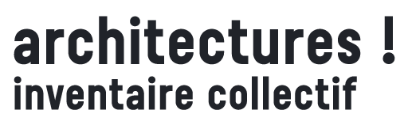

ROADSHOW # WALLONIA – BRUSSELS - EUROPE
technical data sheet

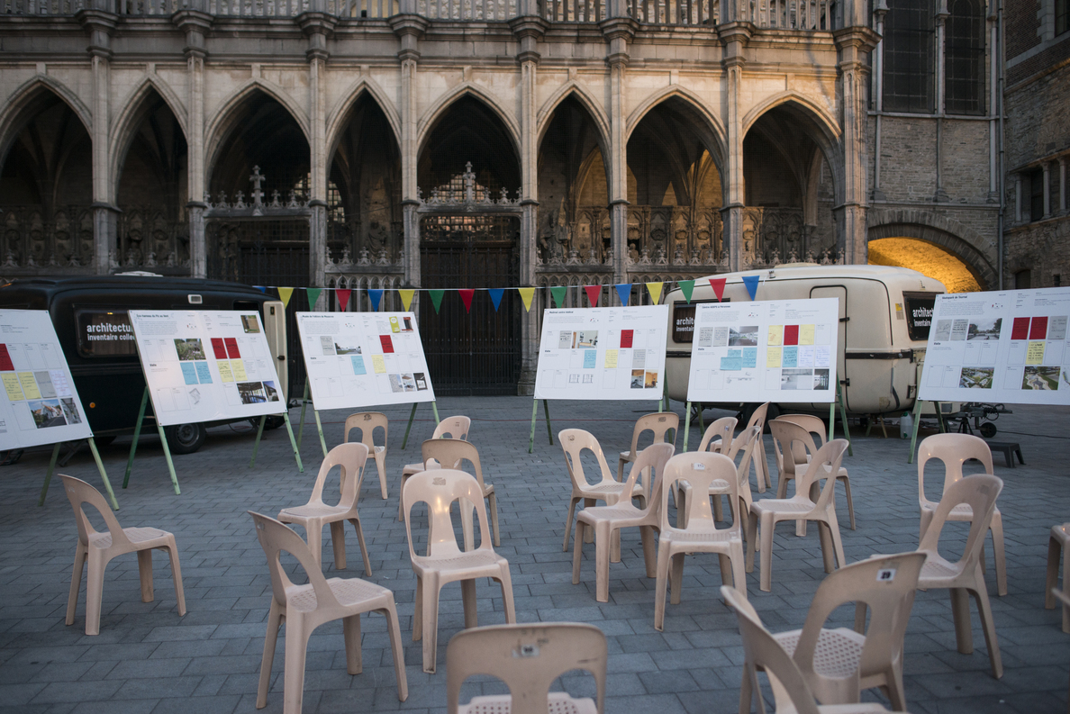
architectures ! inventaire collectif, Tournai step, June 2019 © Mélanie Peduzzi_Habitant.e.s des images

contacts

Curators
Gilles Debrun_practising architect and teacher in the architecture faculty at KU Leuven
gilles.debrun@uclouvain.be 0496 / 554 765
Pauline de La Boulaye_historian, independent exhibition curator paulinedelaboulaye@gmail.com 0470 528 222

an initiative of the Architecture Division of the Wallonia-Brussels Federation
in collaboration with Wallonia-Brussels Architectures
exhibition-encounters based on a book

The aim of the exhibition-encounter architectures ! inventaire collectif is as follows:
- to release and distribute the book.
- to highlight the selection of 45 buildings (homes, co-housing, work places, collective facilities and public areas) and 45 activities (ecological transition, artistic activity, empowerment, temporary occupations) along with their authors.
- to demonstrate the itinerant nature of the inventory in four steps (June to November 2019): covering Tournai, Liège, Pont-à-Celles and Brussels.
- to share thoughts and topics encountered in the street by the organisation Habitant.e.s des images.
- to encourage a debate on architecture in people’s daily lives.

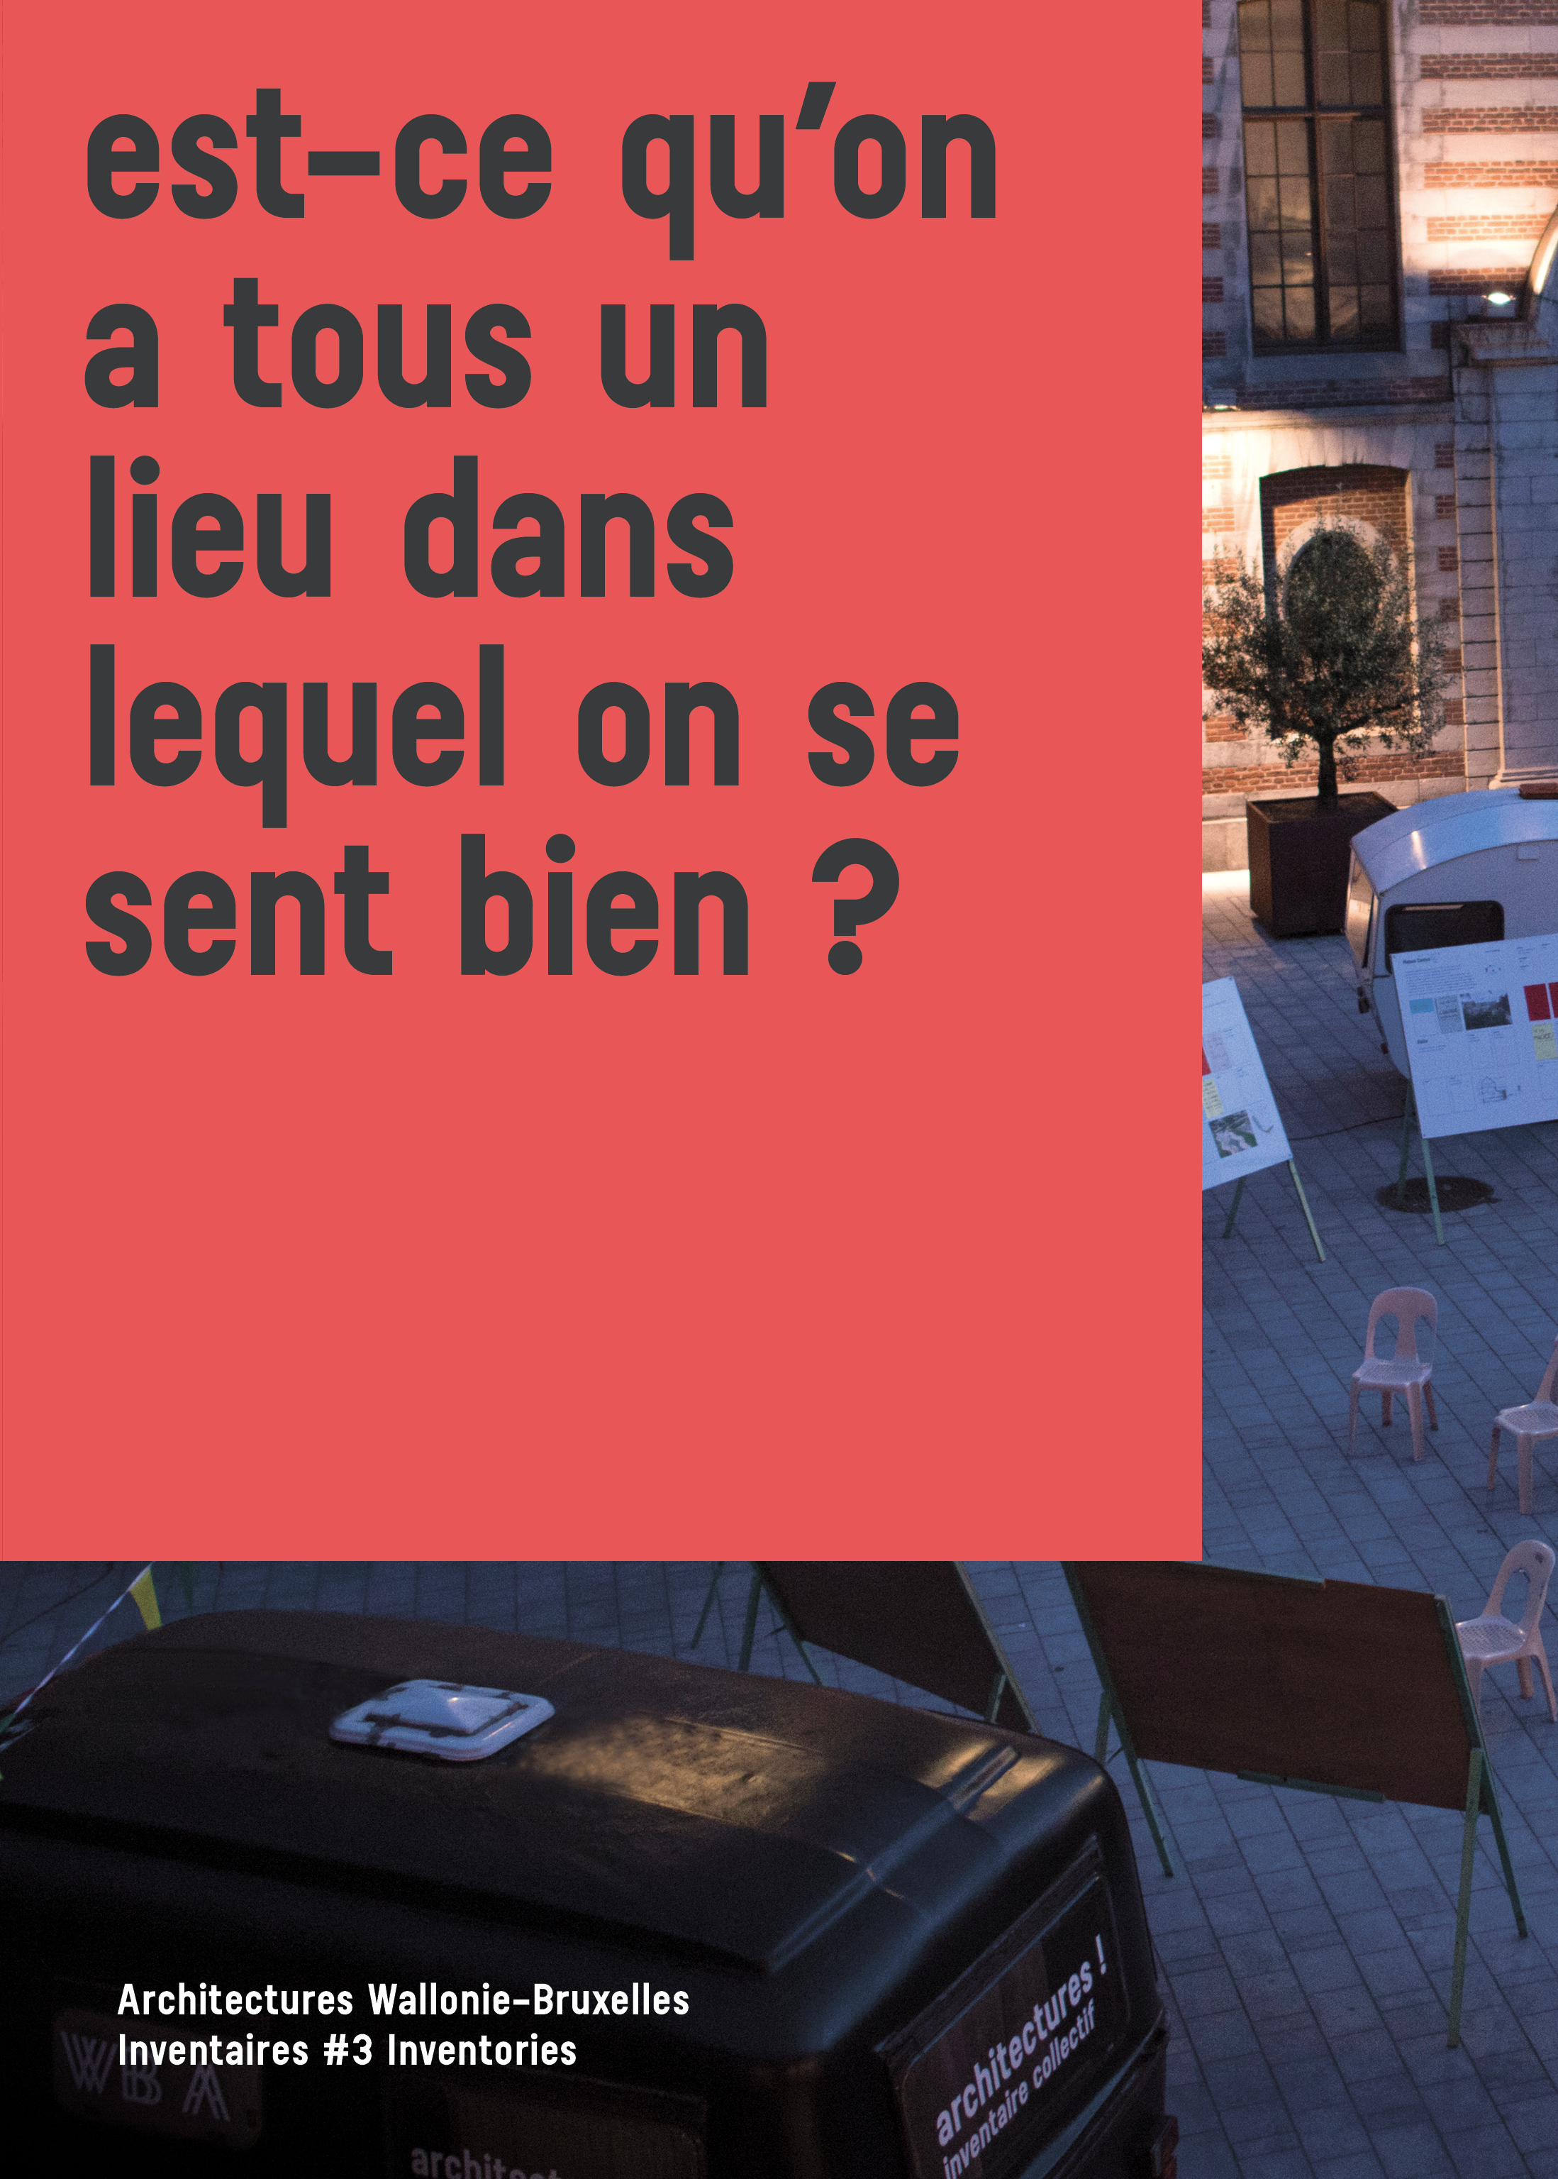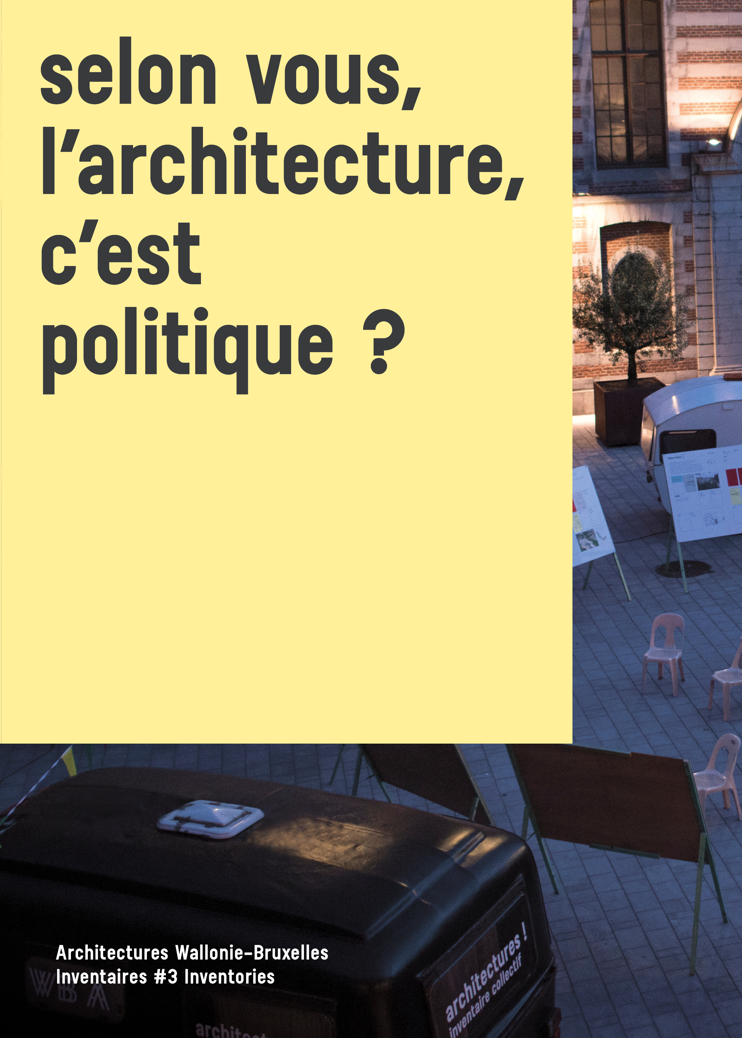
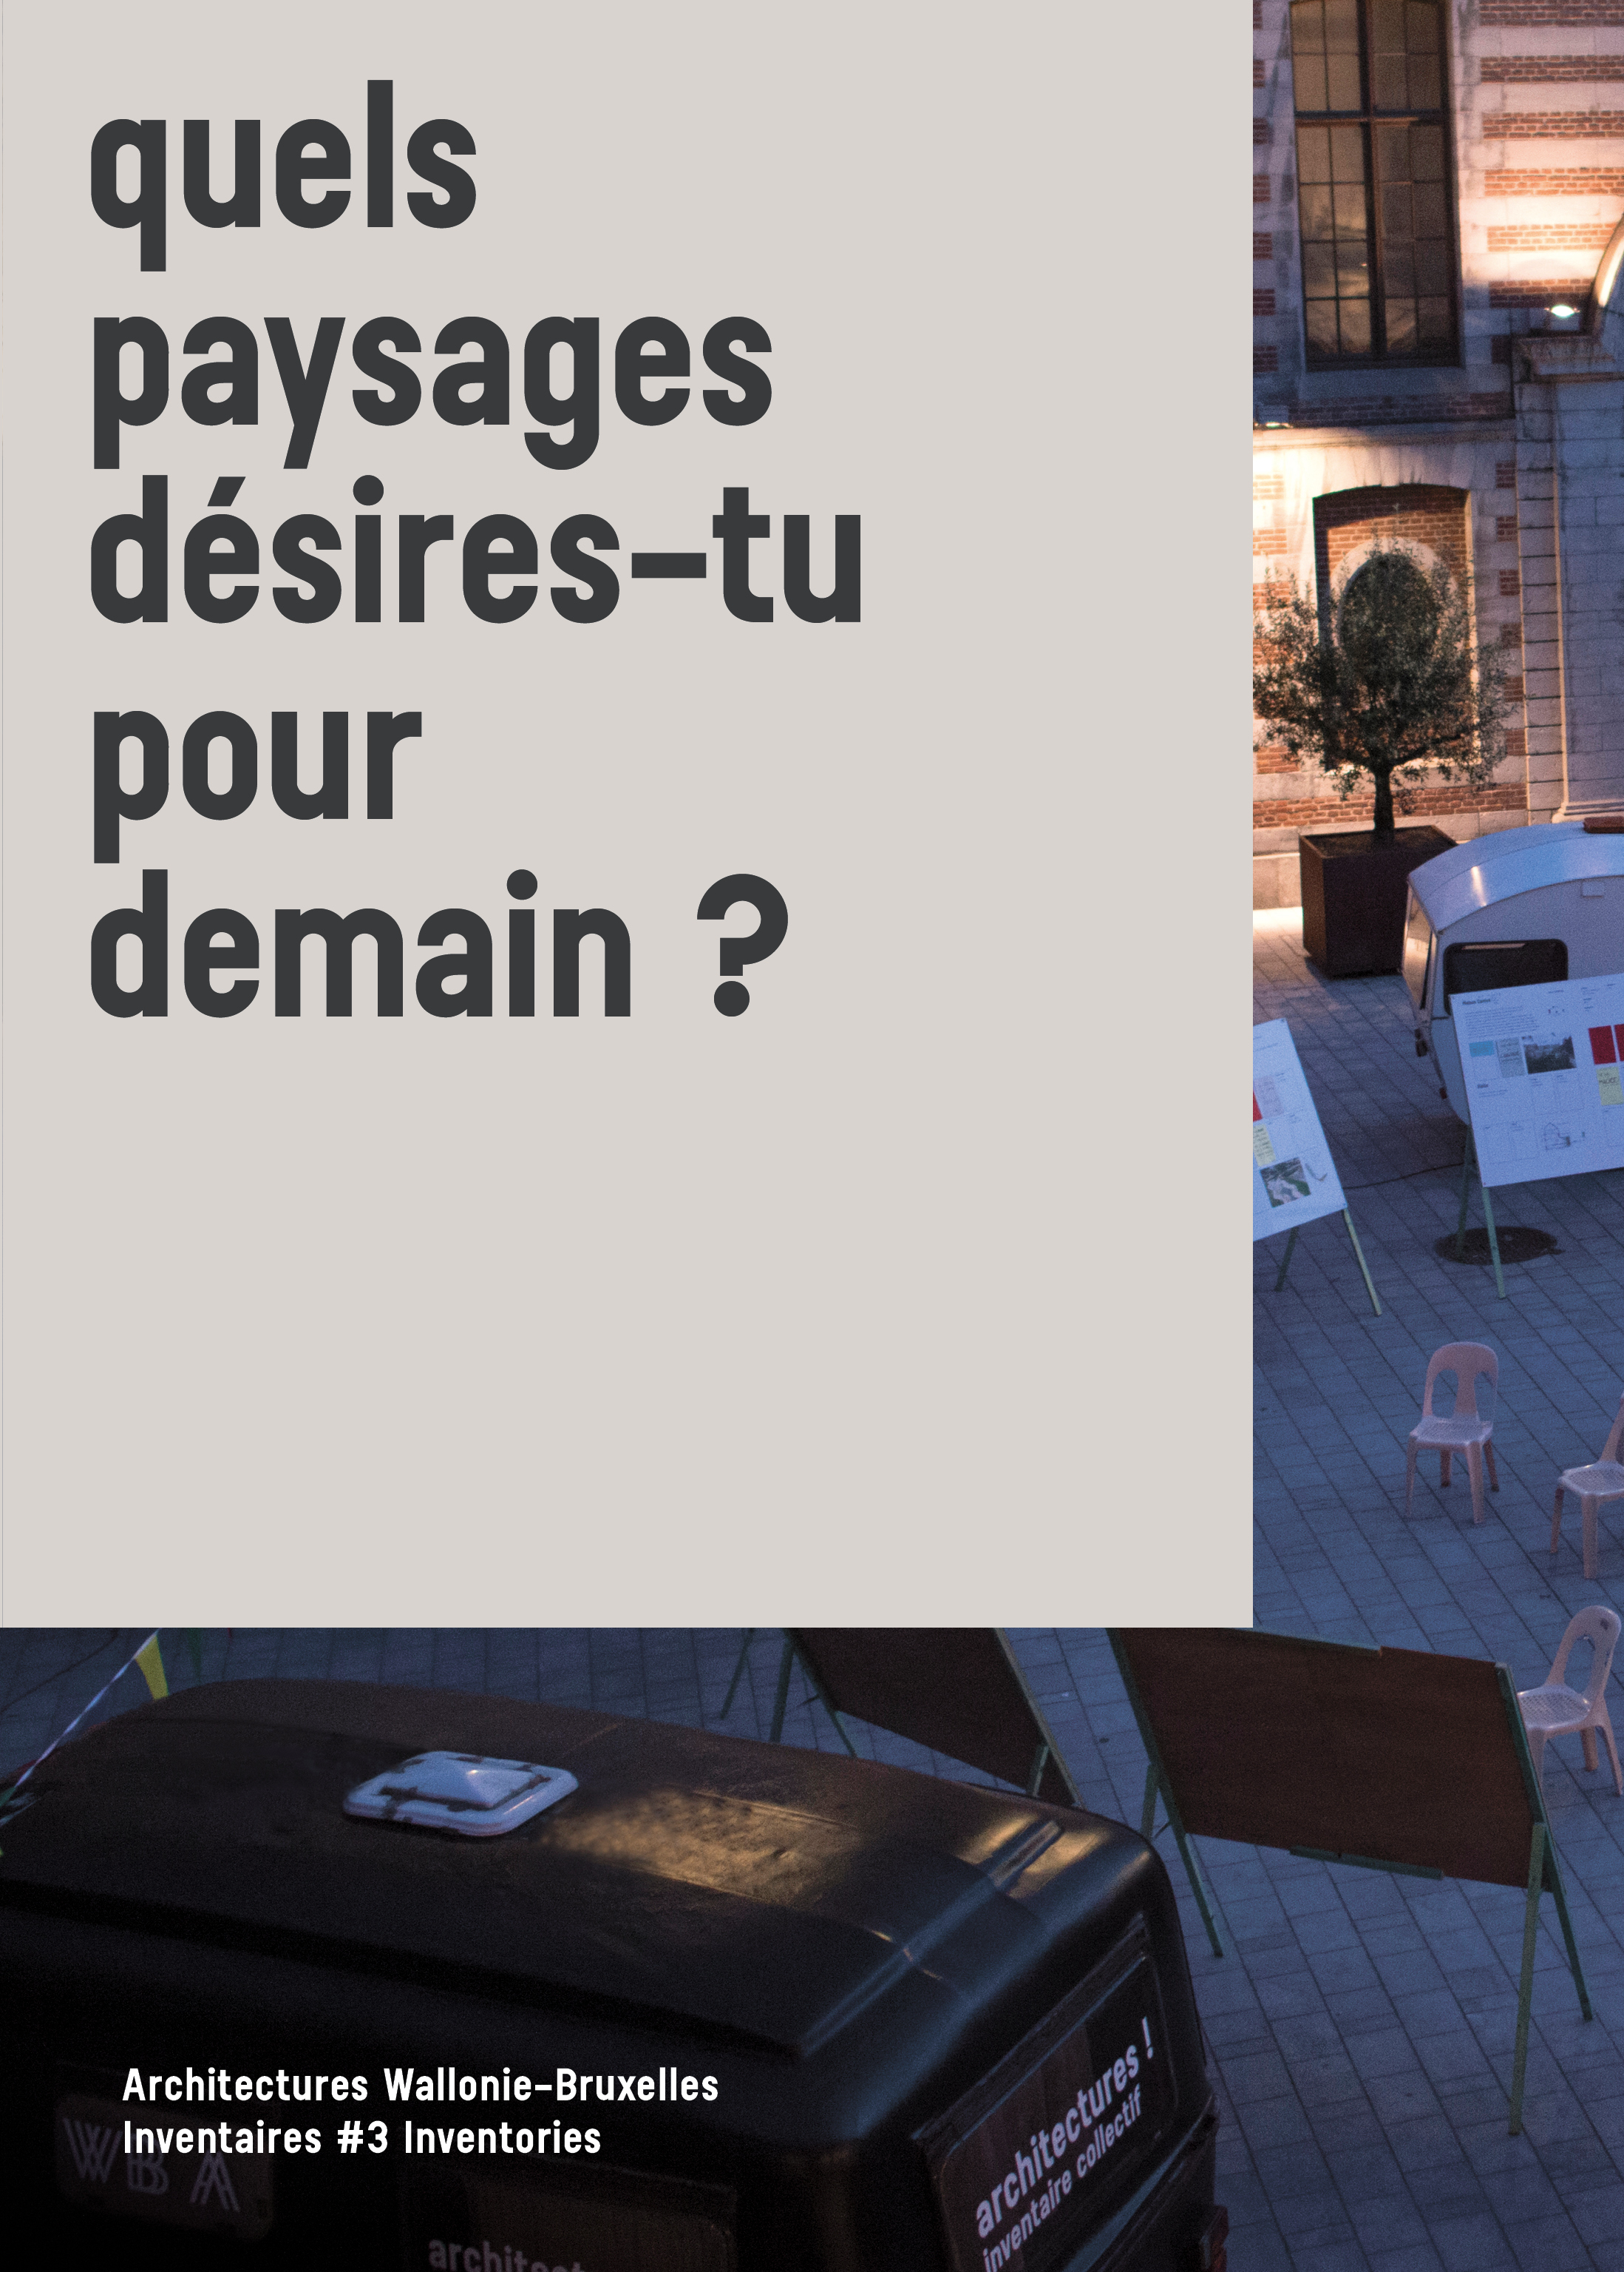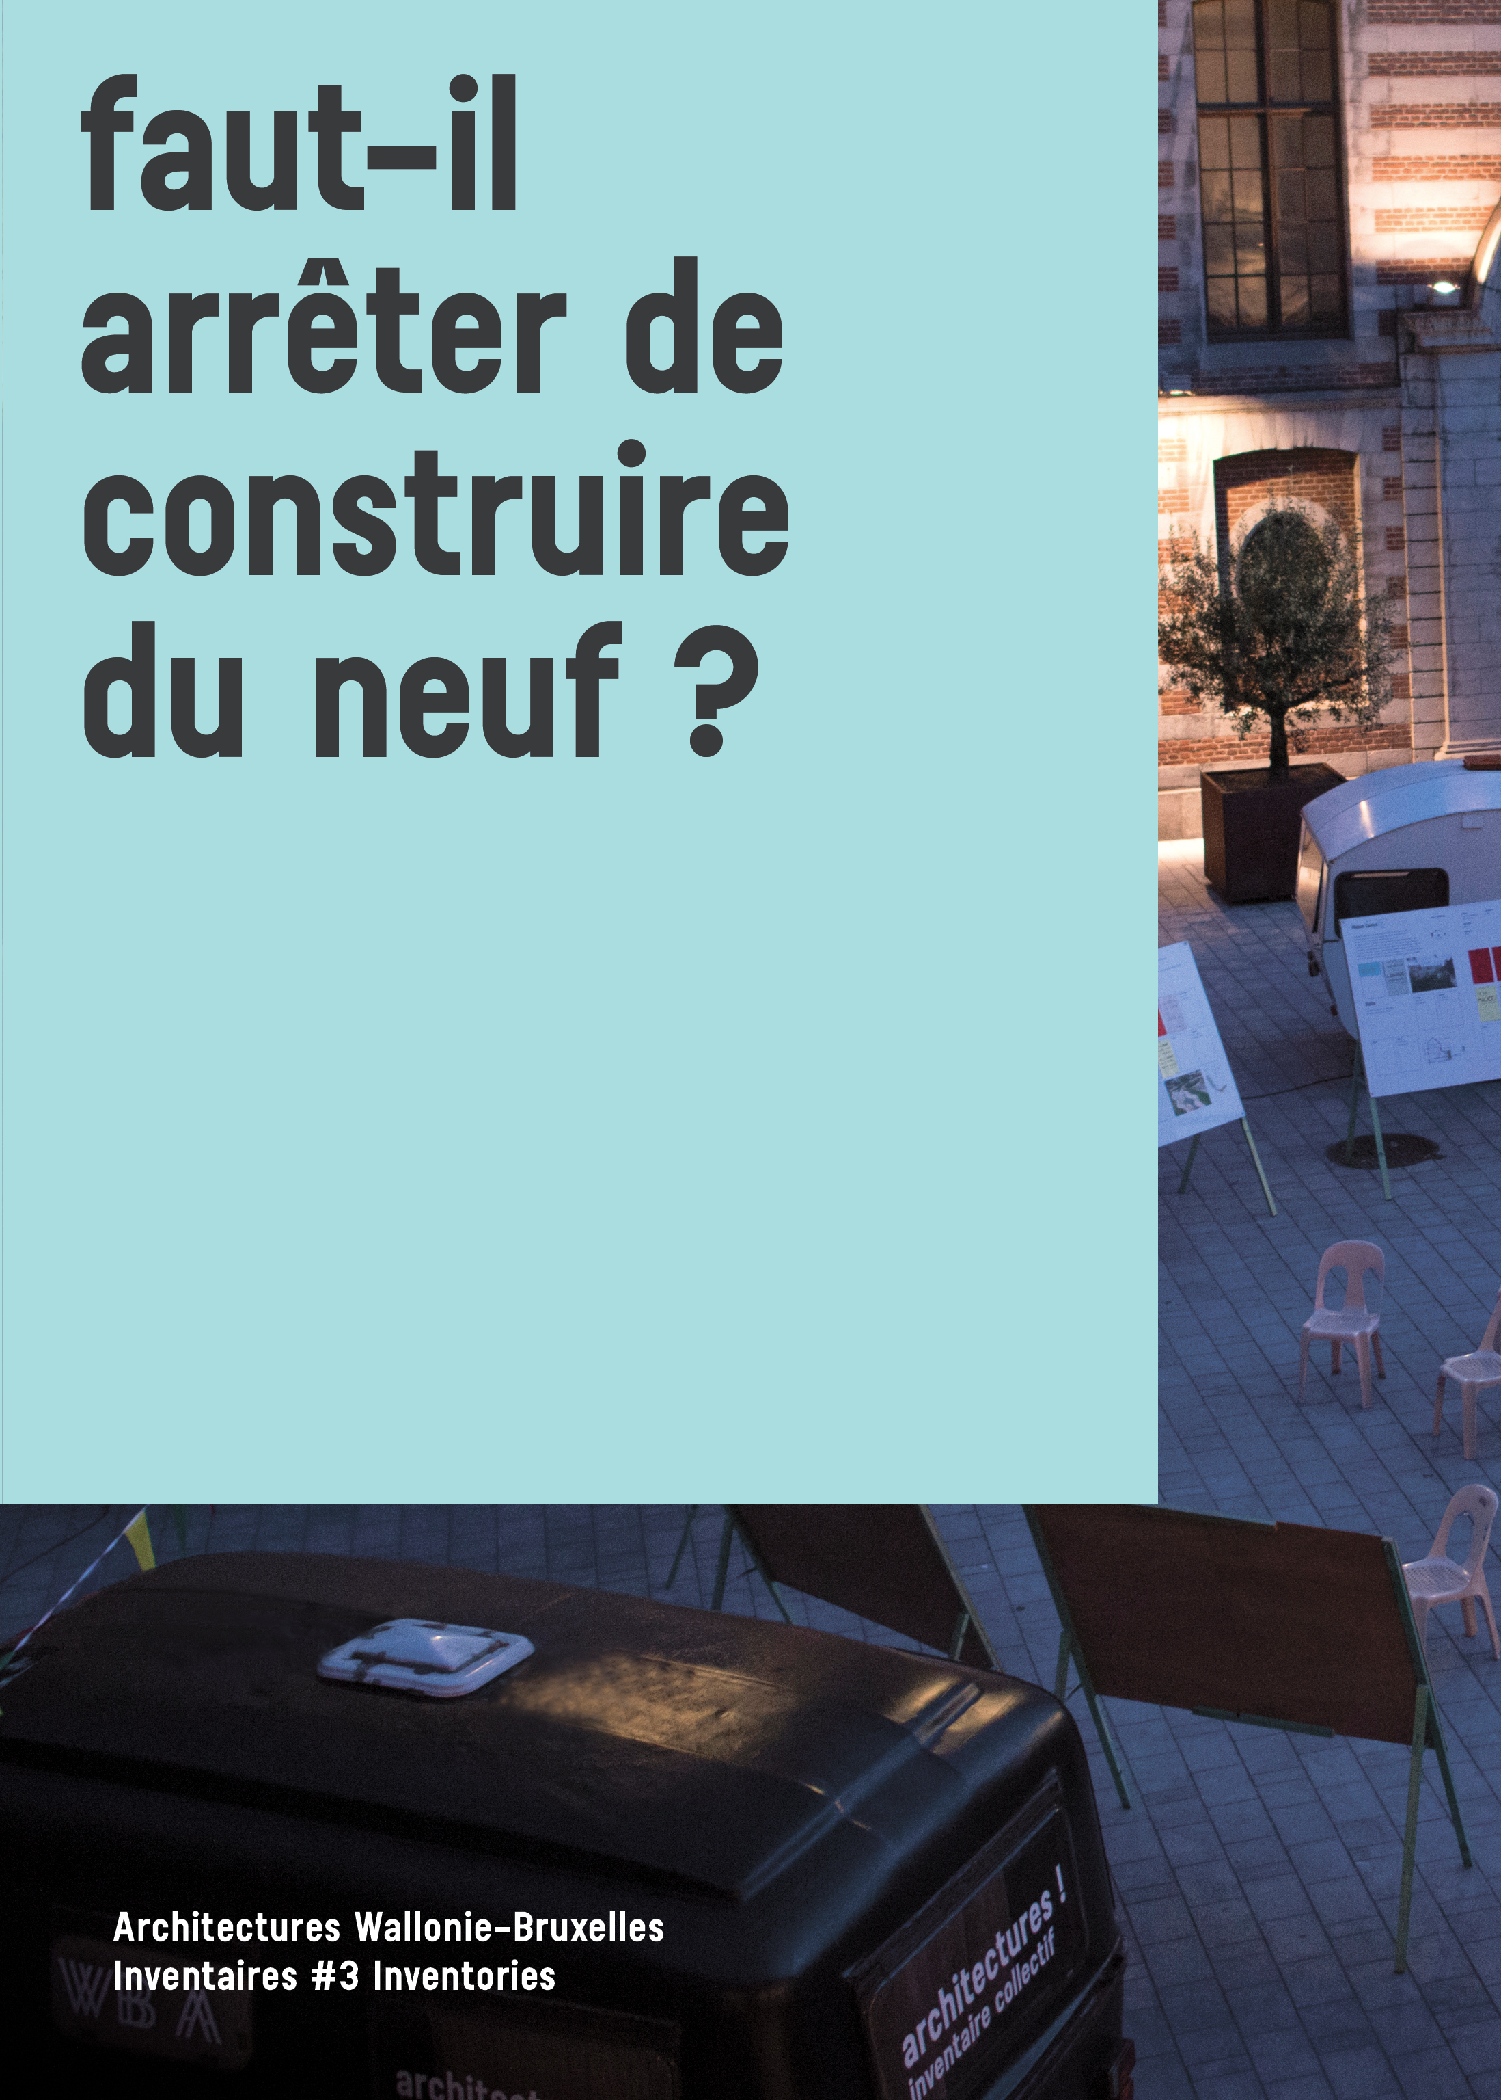
Book presentation
Chosen for the first time by citizen panels, the book features 45 examples of remarkable architecture: homes, co-housing, work places, collective facilities, public areas. The book also describes 45 actions taken to transform our towns, countryside and lives (temporary occupation, artistic projects, urban activism, eco-friendly experiences), along with many testimonials.
This publication is set in the present day and highlights those involved in caring for the land, limiting the use of raw materials, housing sociology, the importance of authorities and negotiation.
Also, the book bears witness to the process perceived by its commissioners Pauline de La Boulaye, historian, and Gilles Debrun, architect, in collaboration with the artistic collective Habitants des Images. Between June and October 2019, they inhabited the public domain 24/7, by installing their caravans, met residents and local authorities, visited buildings, interviewed architects and held local debates with residents and experts.
This choral book includes many quotes and visuals demonstrating a heterogenous portrait of incarnate and benevolent architecture.
Here are some specific and useful ideas to be exploited by those managing towns and cities, countryside and the land, as well as for everyone concerned about the environment.

Collection
Initiated in 2010, the collection Architectures Wallonia-Brussels Inventaires # Inventories aims to create a portrait of recent architecture in Wallonia and Brussels every three years. This collection illustrates the commitment of public authorities and private project owners in researching architecture to suit the modern day and help benefit people’s lives. An edition by the Architecture Cell, in collaboration with the export agency Wallonia-Brussels Architectures (WBA).

Collection Architectures Wallonia-Brussels. Inventaires # Inventories, Volume 4

Editorial team
Collective managed by Pauline de La Boulaye and Gilles Debrun

Authors
Gilles Debrun
Pauline de La Boulaye
Habitant.e.s des images Contributions from architects and residents

Photography
Mélanie Peduzzi, Habitant.e.s des images

Editor
Wallonia-Brussels Federation - Architecture Cell

Contacts
Wallonia-Brussels Federation
Architecture Cell
44, Boulevard Léopold II
B 1080 Brussels
T: + 32 2 413 26 05
lamya.bendjaffar@cfwb.be

Languages
French/English

Format
190 x 260 mm - 384 pages
More than 400 colour photographs

Graphics
Nuno Pinto da Cruz

Printing
IPM printing

Public price
€25

ISBN
978-2-930705-40-8

Legal deposit
D/2020/11.987/2

Distribution
Belgium/Luxembourg
www.adybooks.co
ROADSHOW # WALLONIA – BRUSSELS - EUROPE

Scenography

BOOKS

1 presentation display with 10 books (double panel cut in two and placed back-to-back)

Opportunity for a sales station if managed by the reception.

PANELS

1 double panel (format cut in two and placed back-to-back): introduction + messages of thanks

4 panels-relics from Habitant.e.s des images: social, governance, environment, aesthetic

8 panels presenting 8 selected projects:

- homes
  - FETIS home extension in Brussels Project authors: AUXAU architects
  - ULYSSE renovated farm and home in Tournai. Project authors: Aurélie Hachez Architect

- co-housing
  - ARSENAL renovation of an industrial hall into 24 public residences at Pont-à-Celles. Project authors: LR Architects

- work place
  - WINSON transformation of a castle into a communal building at Fosses La Ville. Project authors: RESERVOIR A , A+11, Piron Architects , Atelier Paysage

- collective facilities
  - TAQUI transformation of a farm into a rural home in Brussels. Project authors: VERS.A,
  - ABBAYE DE VILLERS-LA-VILLE renovation of the visitor centre, trail and gardens. Project authors: Binario architects
  - LEIETHEATER DEINZE cultural centre. Project authors: V+, TRANS

- public area
  - DEJIMA pedestrian walkway in Japan. Project authors: Ney & Partners

>> 2 technical options for the installation of 14 panels (12 large and 2 small):
- transport + insurance WBA
- or remote printing and wall installation by the curators
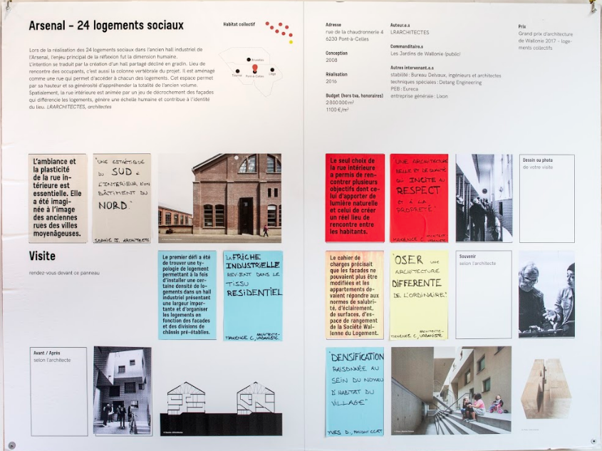
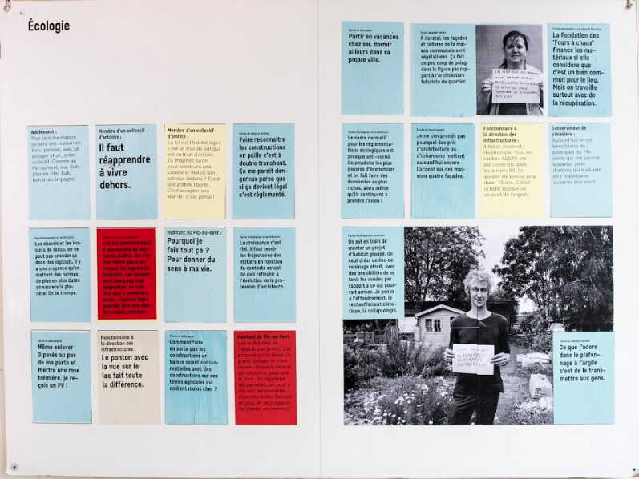
MULTIMEDIA PROJECTION

1 video about the making of the camp in Liège (+/- 6 minutes, film by Anna Lawan)
Technical requirements for projection:
- 1 video projector (supplied by the partner)
- 1 computer or other source (supplied by the partner)

1 slideshow on the 45 selected projects
Technical requirements for projection:
- 1 video projector (supplied by the partner)
- 1 computer or other source (supplied by the partner)

1 slideshow on the 45 selected activities
Technical requirements for projection:
- 1 video projector (supplied by the partner)
- 1 computer or other source (supplied by the partner)

1 screen for consulting the website and facebook page of l’inventaire collectif
+ the map of the 100 preselected constructions and 50 activities (option subject to approval)
Technical requirements for consultation:
- 1 screen (supplied by the partner)
- 1 computer or other source connected to the internet (supplied by the partner)
- 1 table, two chairs (supplied by the partner)

>> Technical requirements for the making of, the slideshows and the consultation screen:
- provision of 3 video projectors and 4 computers by the partner

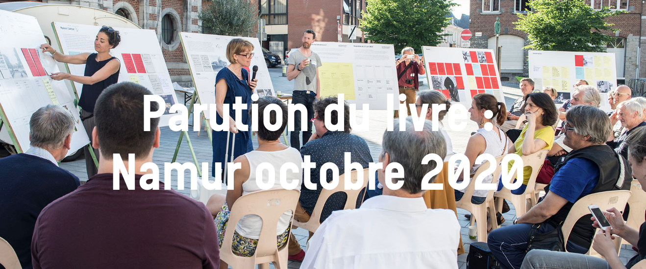

architectures ! inventaire collectif © photo: Mélanie Peduzzi_Habitant.e.s des images

MEDIATION
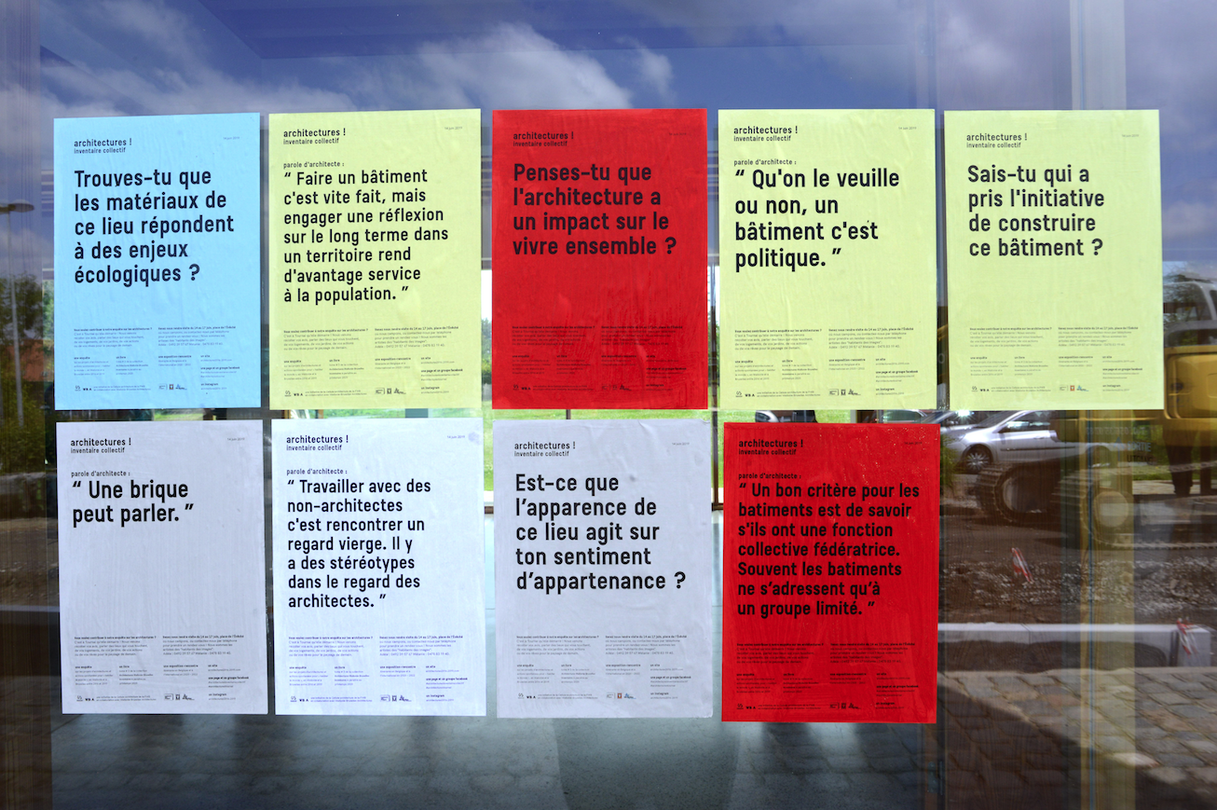

1 or 2 piles of posters/postcards/stickers to take away/stick on site

1 talk with the curators and architects in the selection or those involved in the activities: topic and guests to be decided together with the partner

1 option attached residence Habitant.e.s des images

COMMUNICATION

A press dossier (pdf) is provided by the curators

Options: communication activities (newsletter + teasers + social networks + website update)

Additional option: On-site intervention by Habitant.e.s des images

The artistic duo from Habitant.e.s des images does a street survey, questions residents on their rapport with the architecture. They then disperse portraits and quotes on the town/city walls. This activity is a sign to mark the publication of the book. It reflects the process used for the Inventory.
More specifically, the proposal involves meeting local inhabitants or employees, and allowing informal encounters during which to discuss their rapport with buildings, public spaces, the town/city. This input is then printed in colour on A4 (ecology, social, aesthetic, governance) and hung up in the reception area and on a visible wall in the town/city. This external activity makes it possible to reach passers-by who do use the cultural centre, the library… and to locally integrate the questions posed by the architectural Inventory. A pile of flyers is also provided during the event, which can be taken and hung up by city residents.

Number of quotes: 30 A4 flyers
+ 4 photo portraits A2 b&w
+ 1 pile of flyers

Quotation material:
3074 copies b&w x 0.04 cents = 122.96 euros
paper Clairfontaine 80g (batch of 500) 8.89 euros x 4 colours = 35.56 euros

Quotation service:
Day 0: Preparing the accommodation
Day rate 400 euros x 1p = 400 euros

Day 1: meetings in the street and in people’s homes + hanging up the first flyers
Day rate 400 euros x 2p = 800 euros

Day 2: meetings in the street and in people’s homes + hanging up flyers
Day rate 400 euros x 2p = 800 euros

Day of promotion event: Hanging up selected flyers and photo portraits + photographic documentation
Day rate 400 euros x 2p = 800 euros

Total: 2,958.52 euros

+ kilometre allowance

+ accommodation if necessary

+ requests to partner sites:
- Permission to hang posters in public (minimum 1 wall with a surface area of 4 m2 and in a good location)
- Borrow a ladder

