Wallonia-Brussels Architecture
Inventories # 4
2020-2023
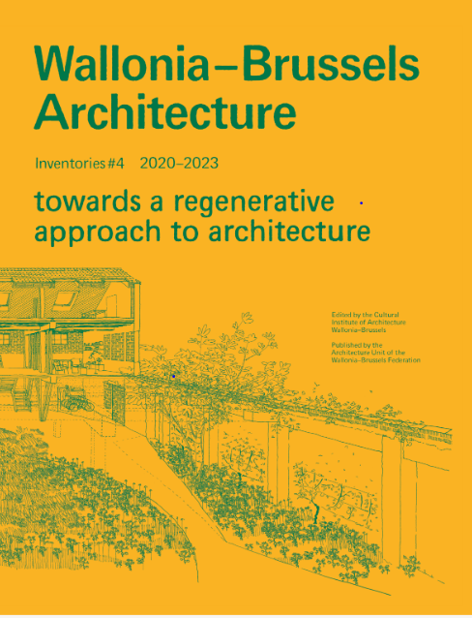
©Ali Ismaïl

Publication The spectre of climate change and its social, economic and ecological implications is haunting the Planet. The energy issue, the drought, the floods and other climatic disasters confront us with the challenges of governance and more specifically, with the lack of political interest in architecture and land planning. In order to try to change the course of this situation, any spatial intervention on our environment, whatever its scale, can no longer fail to meet the challenges of environmental, societal and economic transition by integrating public, collective and private dimensions. With this in mind, Architectures Wallonie-Bruxelles Inventaires # Inventories highlights around one hundred spatial approaches (projects or actions) capable of initiating this transition. They are all located in the French-speaking part of Belgium and abroad and built over the last three years. Different experts point of views in the fields of architecture, urban planning, landscape and sociology unveil some lines of thought following six themes: new rurality, frugality in construction methods, governance, re-appropriation, the role of open spaces and finally, the mutation of architectural practices in relation to the evolution of uses. Those reflections are complemented by the incisive work of the artist Aurélie William-Levaux.
Collection Initiated in 2010, the collection Architectures Wallonie-Bruxelles Inventaires # Inventories aims to draw a portrait of recent architecture in Wallonia and Brussels every three years and to illustrate the commitment of the public authorities and private building owners in the search for architecture that is in tune with the times and contributes to improving the living environment. An edition of the Architecture Unit, produced by the Wallonia-Brussels Cultural Institute of Architecture (ICA-WB) and supported for export by the Wallonia-Brussels Architectures agency (WBA).
TECHNICAL DATA

Editor
Audrey Contesse

Authors
Mathieu Berger
Martina Barcelloni Corte
Oana Bogdan
Christophe Catsaros
Pierre Chabard
Yasmina Choueiri
Audrey Contesse
Carla Frick-Cloupet
Nicolas Hemeleers
Pauline Lefebvre
Norbert Nelles
Anne Norman
Daniela Perrotti
Ward Verbakel
Bernard Wittevrongel

Illustration
Aurélie William Levaux

Graphic Design
Überknackig studio

Publisher
Architecture Unit of the
Wallonia-Brussels Federation

Publisher contact
Architecture Unit of the
Wallonia-Brussels Federation
44, Boulevard Léopold II
B 1080 Brussels
T : + 32 2 413 26 05 - lamya.bendjaffar@cfwb.be

Distribution
ADYBOOKS
ad@adybooks.be - www.adybooks.com

Language
EN

Format
200 x 260 mm - 224 pages

Price
25 €

ISBN
Volume EN : 978-2-930705-48-4

Legal deposit:
Volume EN : D/2023/11.987/3

