Belgian Spirit 2013
Business of Design Week Hong Kong

In the light of Business of Design Week Hong Kong, to which Belgium has been chosen as official partner country in 2013, the three Belgian regions, Brussels, Flanders and Wallonia, have created Belgian Spirit, an initiative to promote Belgian architecture, design and fashion.

To create long term relationships between Belgian Design and counterparts in Hong Kong, Belgian Spirit supports exchange between the two local industries and cooperation between various actors.

We therefore gladly announce:
Chai Wan Creativity Project

Chai Wan is an emerging and dynamic area of creative businesses in the outskirts of Hong Kong.
Its neighbourhood groups a vibrant underground community of designers and creative industries.
Creative businesses are hidden in large warehouses. Due to increasing sky high rents in Central neighborhood, an increasing amount of designers, fashion designers, artists and galleries have relocated or opened their studios here.

Various Chai Wan based studios/businesses – galleries, workshops, concept stores, bookshops, restaurants (please refer to list below) are interested to host and collaborate with Belgian designers and creative talents. This cooperation can provide a great opportunity for Belgians to connect with Hong Kong talent, visit their studios, and organize joint projects and/or exhibitions.

Belgian designers, ready to create solid connections with an established network in the HK designer’s society, are invited to participate in this project. Belgian Spirit will inform on cooperation between Belgian and Hong Kong counterparts via its website and social media.
For more information about this project, contact Sarah Greene - +852 2976 0913 - sarahgreene@asiaone.com.hk. Sarah will help you to set up connections with the Chai Wan Designer’s community.

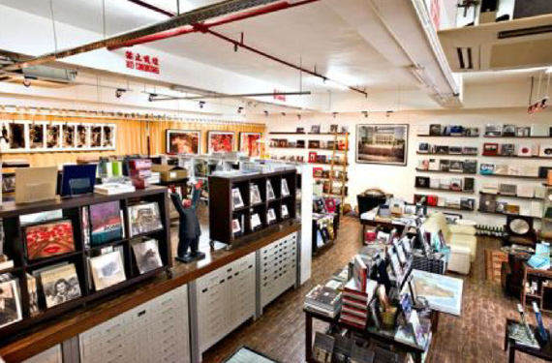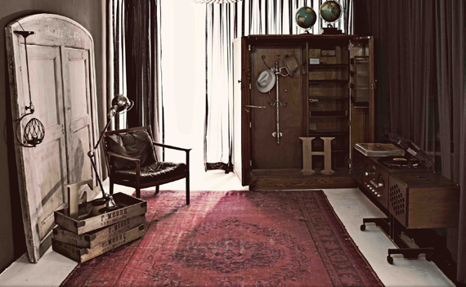
AO-ASIA ONE PHOTO BOOK CENTER

CASA CAPRIZ

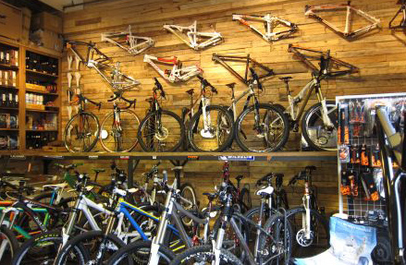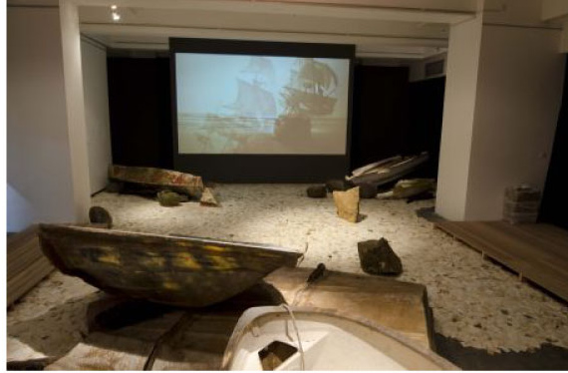
CHRONIC

10 CHANCERY LANE GALLERY ART PROJECT

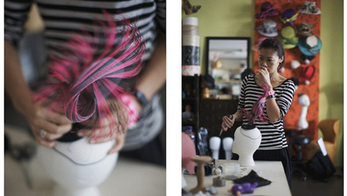
JAYCOW

JAYCOW

Be part of the Belgian Spirit!

www.belgianspirit.com
www.bodw.com.hk

Description of existing activities/businesses in Chai Wan

10 CHANCERY LANE GALLERY ART PROJECT
Type: gallery
Field: contemporary art

10 Chancery Lane Gallery opened its doors in May 2001. The gallery focuses on both established and emerging artists from around the world. We are committed to giving a breath of fresh air to the Hong Kong art scene by bringing works that can expand horizons, open minds and view the world and life in general through various different eyes, ideas and souls. Art is not just decoration for our walls but a connection with our deep inner selves and the world around us.

ANGRY LANE
Type: workshop / concept store
Field: motorcycle

Newcomers to the area, Benoit Barras, along with his brother G and another business partner, opted to open their custom motorcycle workshop in Chai Wan for the same reasons as the other entrepreneurs: to have more space, but also to be a part of a creative community. Angry Lane also sells a carefully curated range of chic biker slash hipster products, from high-end helmets and sunglasses to denim to hand-made leather accessories.

AO-ASIA ONE PHOTO BOOK CENTER
Type: bookshop
Field: photography

One of the region’s most well-known art book publishers, Asia One has a two-year-old bookstore on the ground floor with Hong Kong’s widest selection of specialty photography volumes.

AO-VERTICAL ART SPACE
Type: gallery
Field: contemporary art

Launched in May 2012, AO Vertical Art Space is a ‘vertical flow’ gallery in Hong Kong stretching from 13/F to 3/F, a brand new concept owned by Asia One Communications group. AO Vertical debuted with a photographic exhibition by renowned Chinese photographer Liu Heung Shing and held an important exhibition with renowned photographer Ho Fan.

BONDI BOOKS
Type: Bookshop
Field: photography, art and literature

Newly opened in April, this decade-old, Tokyo-established shop is a dealer in first printings and rare editions of photography, art and literature. Viewing is by appointment only, but owner Josh Carey says he’d be happy to show off some of Bondi’s special stock to interested visitors.

CASA CAPRIZ
Type: showroom
Field: vintage furniture / art

Hidden within an industrial building in the Chai Wan district, Casa Capriz is a spacious 2,600 sq ft showroom opened by Irene Capriz committed to sourcing and selling unique European antiques, vintage furniture and collector’s items. Capriz has brought items from her travels across Asia, Europe and the Middle East, creating an eclectic collection of one-of-a-kind pieces.

CHAIWANESE
Type: restaurant
Field: snacks / coffee shop

Chaiwanese is a pioneering warehouse coffee and eatery space. serving salads, soups, and sandwiches, Chaiwanese focuses on fresh ingredients and handmade food and desserts. With a sea view overlooking Chai Wan’s typhoon harbour, Chaiwanese is a relaxing oasis for the senses.

CHRONIC
Type: concept store
Field: bike

Chronic comes from the world of motor sport, speed, performance, craftsmanship, technology are in or blood. Chronic has brought the same Philosophy to mountain bike business. Chronic chooses the best performance, highest craftsmanship, the latest technology and the quickest mountain bike product to Asia market. A taste of freshness, away from the main stream. Chronic offers you something different, something better.

D-WORKSHOP
Type: workshop
Field: ceramics, leather, fabrics, paper-making etc.

D-Workshop is a personal working and library space. It is also an experimental, multi-function studio for friends to work with materials such as ceramics, leather, fabrics, paper-making, etc.

HONG KONG INSTITUTE OF PROFESSIONAL PHOTOGRAPHERS (HKIPP)
Type: institute
Field: photography

Personal work from 30 of our members, works curated by mr. Lau Ching Ping of gallery Z. Semi-dry bittersweet - Hong Kong is a vibrant city for people to dream, to love and create.

JAYCOW
Type: workshop
Field: millinery (hats)

Jaycow is a Hong Kong based milliner. Jaycow is the pioneer of millinery in Hong Kong, introducing the craft of bespoke millinery to the Hong Kong fashion scene. Jaycow works graces the heads of celebrities, brides and ladies and sometimes men who is not shy to make a statement with a hat or headdress. Jaycow’s studio is a warm and cosy workshop full of interesting millinery hat blocks, materials and fancy hats.

LATITUDE DESIGN STUDIO
Type: workshop
Field: ceramic, graphic design, branding

Jesse Mclin and Julie Progin co-founded Latitude, their Hong Kong based design studio in 2008. Influenced by their American, Swiss and Hong Kong heritage, as well as their diverse backgrounds in textile, product, graphic design and fine arts, Latitude creates home ware collections and bespoke art piece, as well as graphic and visual communication campaigns.

MA CUISINE
Type: restaurant
Field: private kitchen / French gourmet

Located closest to the MTR station of all of these places, Ma Cuisine is the private kitchen arm of French gourmet food and wine purveyor Monsieur Chatte, which has a shop in Sheung Wan and another in Elements. The restaurant is a homely venue with a long wooden table, an open kitchen and a seating area for smaller groups. Reservations required.

PLATFORM CHINA
Type: gallery
Field: contemporary art

Platform China is a multi-function art gallery, established since 2005. It has two gallery/project spaces and five international residency studios (total 1,500sq.m). The main aim of Platform China is to develop and promote contemporary art in China and to build up a platform of cultural exchange and dialogue between Chinese and international artists.

SILLY THING
Type: web magazine, blog
Field: accessories and fashion

Debuting December 2005, THINK SILLY is pacing itself to be one of the leading opinion formers in the international fashion and lifestyle scene.
From July 2008, THINK SILLY blog is transforming itself into THINK SILLY Web Magazine. It is the aim of THINK SILLY Web Magazine to develop a complete and forward-thinking platform for web-based information for the new generation. With the vision of the THINK SILLY editorial team, we collect luxurious lifestyle information and articulate them with in depth cultural research to strengthen our audience’s overall sense and knowledge. Music, films, literature, art and design are some of the major content of THINK SILLY Web Magazine. It is our belief that consumerism should not stand against culture. Rather, the two should be in sync and fulfilling to each other.

TANGRAM
Type: workshop
Field: fashion / design

Tangram is a design studio run by fashion designer Paola Sinisterra and architect and graphic designer Ignacio Garcia. Tangram is a Hong Kong-based contemporary fashion label focuses on creating contemporary women clothing and accessories.. They create beautifully functional clothing and accessories for women, crafted with great care using handpicked materials and unique prints.

TOMMY LI DESIGN WORKSHOP LIMITED
Type: workshop / fashion shop
Field: branding designer, consultant / clothing and footwear

Tommy Li is a branding designer/consultant of the new generation who is renowned for his unique design style, “black humour” and “Audacious visual” designs. One of his various design collections is the contemporary design of Mao art in forms of silk-screen printing, large engraving and sculpture.

UNDERCOVER
Type: concept store
Field: fashion / accessories

Undercover is treasure troves for funky, trendy clothing and accessories for both men and women. Undercover sells only attire and shoes by the Japanese brand of the same name.

UNIT 904
Type: workshop
Field: art

In parallel to Yuk KingTan’s concurrent exhibition at 2P Gallery, the artist will open her studio to show early video artwork and new sculpture, as well as artwork from other artists both international and from Hong Kong. Yuk King Tan was born in Australia, studied art in New Zealand and has shown widely in Europe, America and Asia including large projects at museum of Contemporary Art, Los Angeles and Camden Arts Centre, London. Living in Hong Kong, her work spans diverse materials and media, contemplating the intersection between culture, work and identity.

MICHAEL WOLF
Field: photography

The focus of the well-known German photographer Michael Wolf’s work is life in mega cities. He documents the architecture and the vernacular culture of metropolises. He moved to Hong Kong in 1994 where he worked for 8 years as contract photographer for Stern magazine. He then withdrew from editorial photography in order to pursue his own artistic projects.

X GAME
Type: concept store
Field: extreme sports

X Game, founded in 1991 by Ken Choi, a dedicated sportsman who intends to bring the world’s most exciting Sports into everybody’s lives. X game sells equipment related to XGames.

CHEN MOVANA
Type: workshop
Field: art

Since 2004, Chen Movana has been making “magazine clothes” which are made of old magazines. My idea is to play with deconstructing and reconstructing the shredded magazine papers, so that a certain meaning and content is given to these “magazine clothes”. She focus on exploring “wearable art” by creating “body containers” sculptures, which are to examine the relationship between clothes and the media, and also to reflect on our consumption of disposable commodities. She exhibited worldwide.

